VLMOPSO Mutation Pseudo Code:

Input:

ParticlePosition, iteration, numberOfIters, mutationRatio, p_mutation0, scale

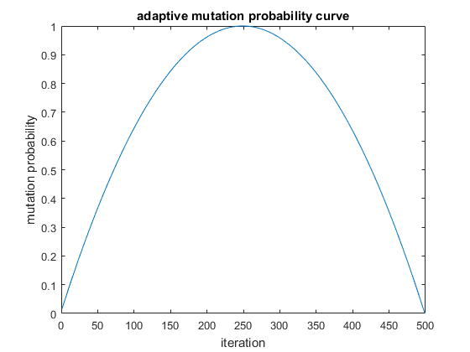Output:

ParticlePosition

Start:

halfItersNum = numberOfIter/2

x = iteration + 1 - halfItersNum

a = 1/(halfItersNum^2)

p_mutation = p_mutation0*(-a*x^2 + 1)

if rand < p_mutation

L= length(ParticlePosition)

Number of mutated members = mutationRatio*L

N= Number of mutated members

mutatedIndices= unifrnd(1,L,1,N)

if rand<0.9

scale = scale*( higherBound- lowerBound)

randNum = randn(1,numberOfMutated)

ParticlePos (mutatedIndices) = ParticlePos (mutatedIndices)+sc.*randNum

else

ParticlePos(mutatedIndices)= unifrnd(lowerBound,higherBound,1,N)

End if

End if

End